Information Visualization Report  
  
Assignment 2, Abboskhon Sobirov  
  
TASK 1:   
  
During Task 1, I utilized ChatGPT moderately to understand each step, and went in that direction when I need help or encountered a problem fetching data:  
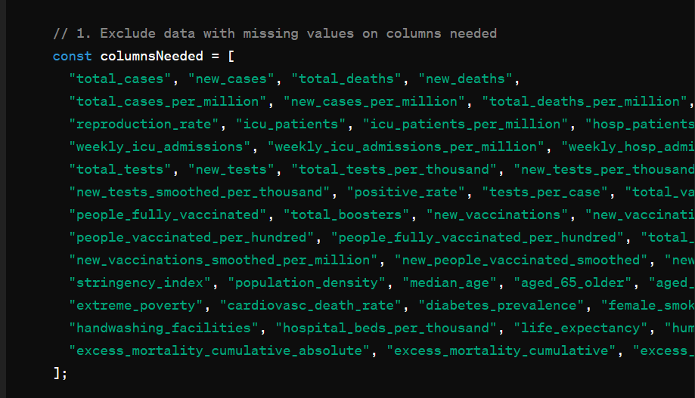As it can be seen, it often gave faulty data. I had to adjust it myself, manually, to tackle the fetching problem.   
  
  
I used it when trying to populate my array with the data from .csv, it is where I learned that I can console.log() every step of the way seeing how my array is being populated.   
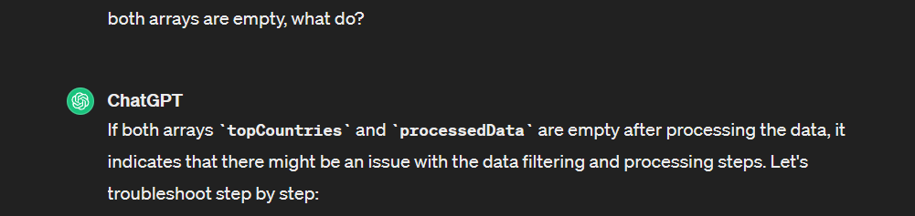And each step I console.log() the array and saw the results, adjusting the code as needed.  
  
  
  
TASK 2:  
  
In task 2, I used ChatGPT much more, because I had troubles getting XScale, YScale to work properly, as my bar was stacked from bottom to top, rather than vertically. Here’s my initial bar.  
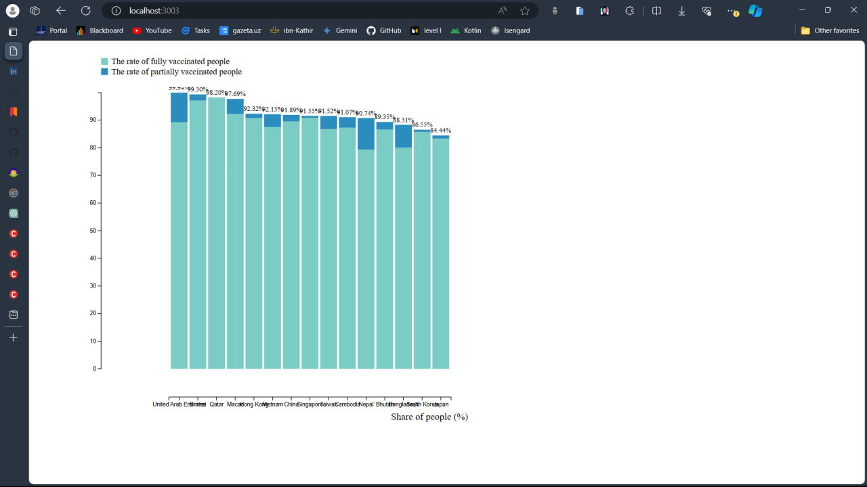I asked ChatGPT to reverse XScale and YScale such that bandwith() does not trhrow erros. But as both XScale and YScale were taken from https://d3-graph-gallery.com/graph/barplot_stacked_basicWide.html, there were some troubles doing it. 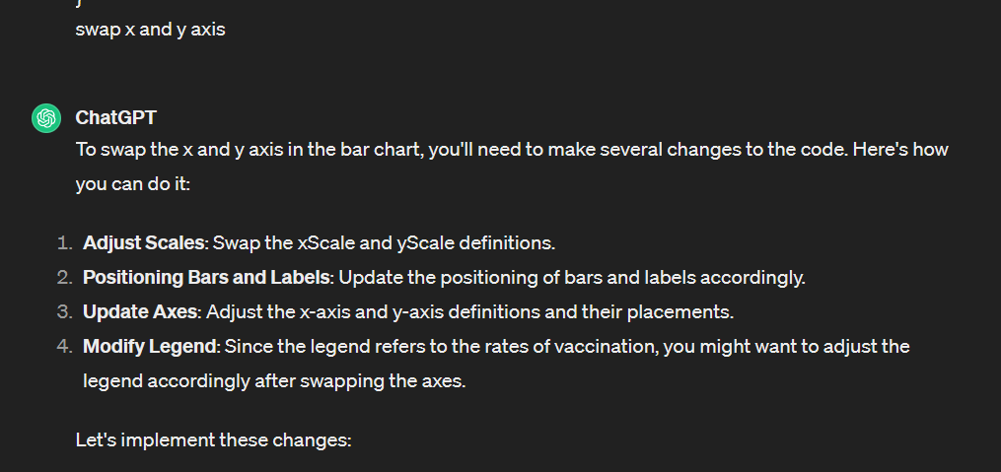Thus, I learned a lot and partnered with ChatGPT in finding ways to fix the challenges that were given by this assignment. I learned a lot, especially about logging ways and data retrieval.